Kate Wiseman at Big DoG

We’ve looked at how important it is to make your word choices interesting when you’re writing. Here are some fun exercises to do in your own time to improve your word choices.

Can you add an alternative word or words to the ones in brackets to make this story more interesting? When there is a space marked with an asterisk (*) you can add any word you like – it’s up to you. I’ve done the first one for you.

I’ve got a friend called Adam. He’s really (nice) –funny and interesting----- . Last weekend, the weather was (bad) ----------------------- and we were bored. His mum is really (nice) -------------------------too, and she offered to take us to the zoo. That made us (happy) ------------------------------.
I hadn’t been to the zoo before. It was (big) ---------------------------- and full of interesting animals. First we went to see the big cats. Adam’s little sister came with us and she was (scared) ------------------------------ of the lions. She said that their (teeth) ------------------------ were too (long and sharp) ------------------------------ and she thought they wanted to (eat) ---------------------------- her. That made us (laugh) ----------------. The tigers were (brilliant). I loved their striped coats. Adam’s mum said the stripes (make them hard to see) ----------------------------- in the jungles and (woods) ------------------- where they live so it’s easier for them to hunt their (animals for food) ------------------------------ .
The penguins looked (silly) ----------------------. They (walked awkwardly) ------------------- around on land, and their black and white feathers made them look like (*)-------------------- . In the water, though, they were completely different. They moved and swam as easily as (*) ----------------- . They (smelt very strongly) ---------------------- of fish.
We were having a (good) --------------------- time until Adam made his mum really (angry)----------------------------- by saying his little sister looked like she belonged in a cage with the (*)---------------------. His mum said that if Adam couldn’t be (nice) --------------------------- she would take him home. So he (said sorry) ---------------------------- , but when his mum went to the loos, he pushed his sister in the (*) ----------------------. That made her (cry) ------------------- .

Positive and negative ways of describing people

This is Charlie, one of the reluctant new pupils at Gangster School. Charlie is very tall and very thin and his hair is always a bit out of control.
Imagine that you knew Charlie and you didn’t like him. How would you describe him, using words that didn’t flatter him?

Instead of saying that he’s very tall and thin, I would say that Charlie is ________________________________________________________________________________________________________________________________________________________________________________________

Instead of saying that Charlie’s hair is out of control, I would say that it is ____________________________________________________________________________________________

Now imagine that Charlie is your best friend. How would you describe him to someone who had never met him?

Instead of saying that Charlie is very tall and thin, I would say that he is ________________________________________________________________________________________________________________________________________________________________________________________

Instead of saying that Charlie’s hair is out of control, I would say that it is ___________________________________________________________________________________________
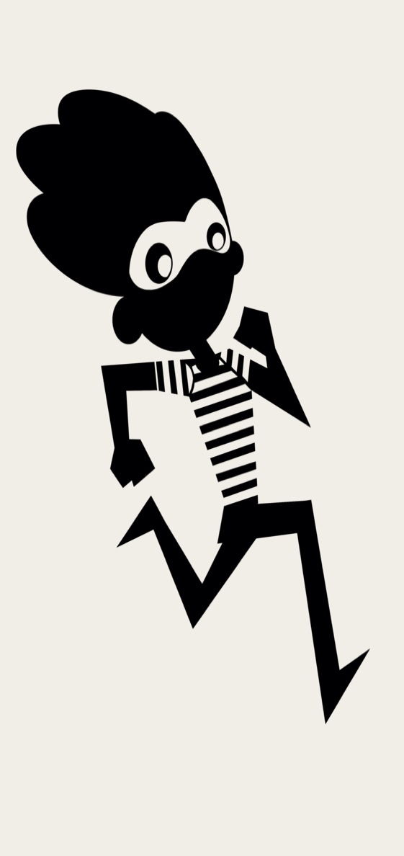

Similes and Metaphors

Now, take a look at the villain you designed during our session together. Imagine you are writing a story about them and you want to describe your villain in ways that make him or her easy for your reader to imagine.
Similes and metaphors can be really helpful here. Similes are when you say that something is SIMILAR to something else, for instance, the vampire’s fangs were as sharp as daggers. Metaphors are when you say that something IS something else, for instance, the vampire’s fangs were daggers. Often they have a stronger effect than similes. 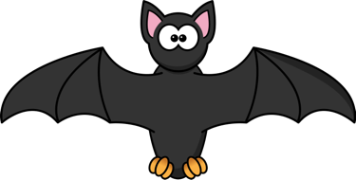

Can you use similes and metaphors to describe your villain?
- My villain’s eyes are -------------------------------------------------------------------------------------
- My villain’s nose is ---------------------------------------------------------------------------------------
- My villain’s mouth is ------------------------------------------------------------------------------------
- My villain’s teeth are ------------------------------------------------------------------------------------
- My villain’s skin is ----------------------------------------------------------------------------------------
- My villain’s hair is ----------------------------------------------------------------------------------------

Now pretend you are talking to your villain and you’re scared of him/her. How can you describe their features in ways that won’t offend them, without actually lying?

- Your eyes are ---------------------------------------------------------------------------------------------
- Your nose is ------------------------------------------------------------------------------------------------
- Your mouth is ----------------------------------------------------------------------------------------------
- Your teeth are ---------------------------------------------------------------------------------------------
- Your skin is -------------------------------------------------------------------------------------------------
- Your hair is -------------------------------------------------------------------------------------------------

Well done! Your villain is pleased with you and you will survive another day!

